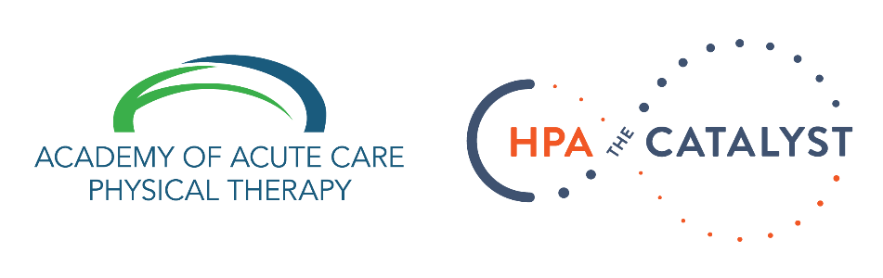
WEBINAR

Acute Care Physical Therapy and COVID-19: How Can We Add the Greatest Value?
March 21, 2020
2 hour duration

VIEW THE WEBINAR RECORDING
(You’ll be prompted to enter your name and email and then the recording will start)

About the Webinar:
Novel pandemics create great opportunity to challenge the way we utilize our professions’ resources and knowledge bases. As we learn more each day about Coronavirus and COVID-19, we must also push ourselves to rethink how we can best provide care in the hospitals. No one has the answers, but join us for a discussion designed to explore some of these challenges and discuss different perspectives. Topics include: managing and triaging physical therapy resources during pandemic, caring for the critically ill, physical therapy in the emergency department, lessons learned from national health leaders, and caring for yourself in stressful times.

Resources:
- Many valuable references and resources in this Google Doc.
- The slide presentation used during the webinar.

Presented by:
Kyle Ridgeway, PT, DPT, CCS
Clinical Specialist
University of Colorado Health Medical Center

Brian Hull, PT, DPT, MBA
Director of Rehabilitation
Baylor University Medical Center
Baylor Scott & White Institute for Rehabilitation

Special Guests:
Jim Smith, PT, DPT
Professor of Physical Therapy
Utica College

Patricia J Ohtake, PT, PhD
Assistant Vice President for Interprofessional Education
Office of the Vice President for Health Sciences and Associate Professor, Physical Therapy Program Department of Rehabilitation Science
University at Buffalo

Megan Mitchell, PT, DPT
HERT Team Lead
Denver Health

L. Maurine Coco, PT, MSPT
Director of Rehabilitation Services
University of California, San Francisco

John R. Corcoran, PT, DPT, MS
Site Director for Rehabilitation Therapy Services
Clinical Assistant Professor
NYU Langone Health
Rusk Rehabilitation

